CPUT/FID/PFD470S|PFD471S|PFD472S

STUDENT Sesihle Jack  FULL NAME: | STUDENT  NUMBER: 211287393
SUBJECT:  PFD47XS Professional Development/Methods | TEST DATE: JUNE 2022 | DURATION:  3 hours


Test 2

FACULTY OF INFORMATICS & DESIGN
COURSE:

BTech in Information Technology
Question | Student Mark | Max. Score
1 |  | 20
2 |  | 20
3 |  | 20
4 |  | 20
5 |  | 20
 |  | 100

SUBJECT COORDINATOR:

Mr T. Makhurane

LECTURERS / EXAMINERS:

Mr T. Makhurane

MODERATOR:

Internal: External:

%
SPECIAL INSTRUCTIONS:

🖝Answer all the questions that are written in bold.

REQUIREMENTS:

🖝Students should not leave within the first hour even if they have completed.

🖝 Hand-in question paper together with the answer book at the end of examination

Question 1 |  | [20]
1.1 | - Explain how Mintzberg’s managerial roles can be used to describe the work of a project manager.  1.Interpersonal Roles  - The Figurehead: performs ceremonial duties. Examples: greeting visiting dignitaries, attending an employee’s wedding, taking an important customer to lunch.  - The Leader: responsibility for the work of subordinates, motivating and encouraging employees, exercising their formal authority.  - The Liaison: making contacts outside the vertical chain of command including peers in other companies or departments, and government and trade organization representatives.  2.Informational Roles  - Monitor : scans the environment for new information to collect.  - The Disseminator: Passing on privileged information directly to subordinates.  - The Spokesperson: Sharing information with people outside their organization. Examples: a speech to a lobby or suggesting product modifications to suppliers.  3.Decisional Roles  - The Entrepreneur: Seeks to improve the unit by initiating projects.  - The Disturbance Handler: Responds involuntarily to pressures too severe to be ignored. Examples: a looming strike, a major customer gone bankrupt, or a supplier reneging on a contract.  - The Resource Allocator: Decides who gets what.  - The Negotiator: Committing organizational resources in “real-time” with the broad information available from their informational roles. | [8]
1.2 | List and briefly explain the functions of management as described by Henri Fayol.  - To be Prevoyant  - . Investigative the future and picture up a plan of action. The elements of strategy  - To organize  - Build up the structure, both material and human, of the undertaking  - To command  - Maintain the activity among the personnel  - To coordinate  - Binding together, unifying and harmonizing all activity and effort  - To control  - Seeing that everything occurs in conformity with established rules and expressed commands | [6]
1.3 | Provide a list of the archetypal role players that participate software development projects. Include a brief description of each role; and explain why that role is necessary.  Systems are created to solve a specific problem or meet a specific need. A development team is in charge of determining the system's specific goals and, in the end, delivering a system that achieves these goals. Users, managers, system analysts, programmers, technical specialists, and other stakeholders are common members of a development team. Each of these parties has a specific function to fulfill. | [6]
Question 2 |  | [20]
2.1 | Describe the Waterfall life cycle model and the Unified process model. Compare and contrast these lifecycle models.  The Waterfall Model is a sequential model for software development that divides the process into pre-defined phases. Each phase must be completed before the next one can begin, and the phases must not overlap. During the SDLC phase, each phase is designed to perform a specific activity. When requirements do not change frequently, the waterfall methodology can be used. The application is not difficult to use and is quite large. The project is short, and the requirements are clear.  Unified Process is based on multiple iterations of enlarging and refining a system, with cyclic feedback and adaptation. Iterative and incremental software development refers to the process of developing a system incrementally over time, iteration by iteration. The iterations are divided into four phases, each of which contains one or more iterations. The Unified Process is an extensible framework that should be customized for specific organizations or projects, rather than just a process.  To compare these two Unified Process Less time is required for integration as the process of integration goes on throughout the software development life cycle. While waterfall Simple and easy to understand and use. And Easy to manage due to the rigidity of the model, each phase has specific deliverables and a review process the disadvantage of waterfall is that, once an application is in the testing stage, it is very difficult to go back and change something that was not well-thought out in the concept stage. For unified process the development process is too complex and disorganized. | [10]
2.2 | Briefly describe the IEEE 1074 Standard for Developing Software Life cycle Processes. Include an explanation as to why this standard was necessary.  The IEEE 1074 framework is an IEEE standard for defining software lifecycle models that was first published in 1997. The IEEE 1074 standard does not attempt to define a lifecycle model; rather, it specifies which sub-processes should be included in one. Any organization that manages and executes software projects will benefit from 1074. Configuration management, metrics, quality assurance, risk reduction, and the acts of estimating, planning, and training are all essential processes. The creation of the SLCP is primarily the responsibility of the project manager and process architect for a given software project.  From concept exploration to software system retirement, the activities described in the 1074 mapping table cover the entire life cycle of a software project. Nonsoftware activities such as contracting, purchasing, and hardware development are not covered by 1074. It also doesn't specify which SLCM should be used. 1074 assumes that the project manager and process architect are already familiar with a number of SLCMs, as well as the criteria for selecting them, as well as the criteria for determining the desired end system's attributes and constraints, as well as the development environment that influences this choice. | [10]
Question 3 |  | [20]
Given the following cash flow situation

Year Cash Flow 0 R -200000.00
1 R 40000.00
2 R 40000.00
3 R 40000.00
4 R 40000.00
5 R 40000.00
6 R 40000.00
7 R 40000.00
3.1 | What is the payback period associated with this project?  Pp =-200000/40000 = -5 = 5 years | [2]
3.2 | Given an applicable rate of interest of 8%, what is the Net Present Value associated with this project?  PV1 = FV / (1 + i) ^n  40000/(1 + 0.08)^1 =  40000/(1.08)^1 = R37037.04  PV2 = FV / (1 + i) ^n  40000/(1 + 0.08)^2 =  40000/(1.08)^2 = R34293.55  PV3 = FV / (1 + i) ^n  40000/(1 + 0.08)^3 =  40000/(1.08)^3 = R31753.29  PV4= FV / (1 + i) ^n  40000/(1 + 0.08)^4 =  40000/(1.08)^4= R29401.19  PV5 = FV / (1 + i) ^n  40000/(1 + 0.08)^5 =  40000/(1.08)^5 = R27223.33  PV6 = FV / (1 + i) ^n  40000/(1 + 0.08)^6 =  40000/(1.08)^6 = R25206.79  PV7 = FV / (1 + i) ^n  40000/(1 + 0.08)^7 =  40000/(1.08)^7 = R23339.62  37037.04 + 34293.55 + 31753.29 + 29401.19 + 27223.33 + 25206.79 + 23339.62 = 208254.81  NVP = - 200000 + 208254.81 = R8254.81 | [8]
3.3 | With suitable working, provide an estimate of the internal rate of return. | [10]

Question 4 [20]

4.1

Draw the network.
Activity | Immediate Predecessors | Optimistic | Most Likely | Pessimistic
A | - | 42 | 50 | 55
B | A | 15 | 32 | 42
C | A | 41 | 43 | 47
D | B | 64 | 78 | 88
E | B | 40 | 45 | 58
F | C, D | 2 | 4 | 7
G | E | 12 | 17 | 23
H | E, F | 20 | 24 | 25

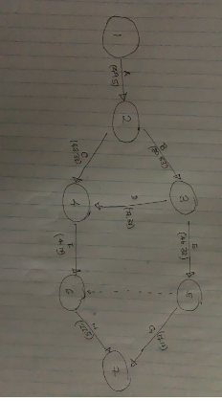

[6]

  - Determine the expected finish time. [6]
E1=0
E2=E1+t1,2 [t1,2=A=49.5]=0+49.5=49.5
E3=E2+t2,3 [t2,3=B=30.83]=49.5+30.83=80.33
E4=Max{Ei+ti,4}[i=23,]
=Max{E2+t2,4;E3+t3,4}
=Max{49.5+43.33;80.33+77.33}
=Max{92.83;157.66}
=157.66
E5=E3+t3,5 [t3,5=E=46.33]=80.33+46.33=126.66
E6=Max{Ei+ti,6}[i=45,]
=Max{E4+t4,6;E5+t5,6}
=Max{157.66+4.17;126.66+0}
=Max{161.83;126.66}
=161.83
E7=Max{Ei+ti,7}[i=56,]
=Max{E5+t5,7;E6+t6,7}
=Max{126.66+17.17;161.83+23.5}
=Max{143.83;185.33}
=185.33
=185 DAYS

  - Calculate the time by which we have 95% confidence of finishing. [4]
P(z) = 0.95
Z= 1.645
X= (1.645) (7.46) + 185 =197.27

=197.27 DAYS

  - Calculate the probability of finishing 2 days after the expected finish time [4]

Z = 187-185/7.46
=0.27
z= 0.6064
=0.6064 X 100
= 60.64 %

Question 5 [20]

Given the information provided here and the Gantt chart layout provided below, construct a Gantt chart, by filling in the appropriate blocks on the Gantt chart with the character X on this question paper.

Assume the following:
    - There are 20 Working days per month.
    - There are 8 hours per working day. Hint
    - For the Gantt chart each block represents 5 days

Activity Letter | Activity Description | Predecessor | Duration (days)
A | Train project team | None | 10
B | Project paperwork and systems design | A | 15
C | Modify purchased package | B | 5
D | Manual systems flow | B | 20
E | Modify in-house procedures | B | 15
F | Test and implement modifications to purchased package | C | 20
G | Test and implement manual | D | 15
H | Test and implement modifications to in-house procedures | E | 25

CPUT/FID/PFD470S|PFD471S|PFD472S

(Gantt Chart) Description |  | December |  |  |  | January |  |  |  | February |  |  |  | March |  |  |  | April |  |  |  | May |  |  |  | June |  |  |  | July
A. Train Project Team |  | X | X
B. Project Management Paperwork |  |  |  | X | X | X
C. Modify Purchased Package |  |  |  |  |  |  | X
D. Manual Systems Flow |  |  |  |  |  |  | X | X | X | X
E. Modify In-House Procedures |  |  |  |  |  |  | X | X | X
F. Test and Implement Modifications to Purchased Package |  |  |  |  |  |  |  | X | X | X | X
G. Test and Implement Manual Systems Flow |  |  |  |  |  |  |  |  |  | X | X | X
H. Test and Implement Modifications to In- House Procedures |  |  |  |  |  |  |  |  |  | X | X | X | X | X

Given this resource sheet

Resource | Cost/Hour
Trainer | R50.00
Application Domain Specialist | R40.00
Solution Domain Specialist | R40.00
Project Manager | R20.00
Tester | R30.00

And this task assignment List

Task | Resources Assigned
A. Train Project Team | Trainer50 X8 X10 =4000
B. Project Management Paperwork | Project Manager 20X 8X15 = 6000
C. Modify Purchased Package | Solution Domain Specialist, Application Domain  Specialist 40X8 + 40X8 X 5 =3200
D. Manual systems Flow | Project Manager 20 X8 X 20 =3200
E. Modify In-House Procedures | Project Manager, Solution Domain Specialist  20 X8 + 40X 8 X15 = 7200
F. Test and Implement Modifications to  Purchased Package | Tester, Solution Domain Specialist  30 X 8 + 40X 8 X 20 = 13 200
G. Test and Implement Manual Systems Flow | Tester 30X8 X15 = 3600
H. Test and Implement Modifications to In-  House Procedures | Tester 30X 8X25 = 6000

Assess the total amount of money needed to run the project. [20]

R4000 + R6000 + R3200 + R3200 +R7200 + R13 200 + R3600 + R6000 =R41 000

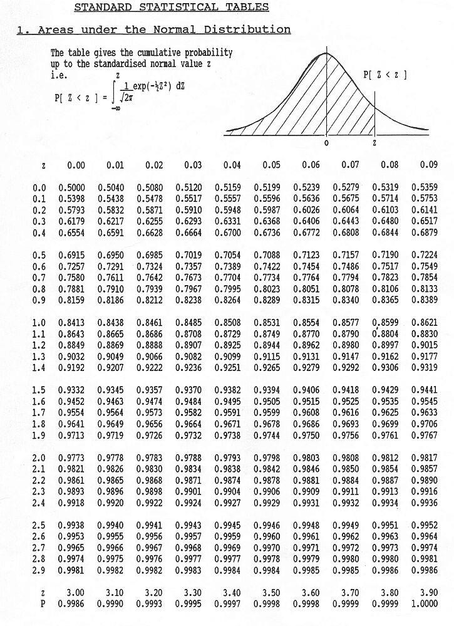

Some Formulas

𝐹𝑉

A + 4M + B

⎛ B − A ⎞2

x − μ

𝑃𝑉 = (1 + 𝑟)^{𝑛}
ED =

6
Variance = ⎜

⎝
⎟ z =
⎠ s
6

